Case 1-Eur-Czech Republic, Dolní Věstonice-Venus-Clay-29-25 kya

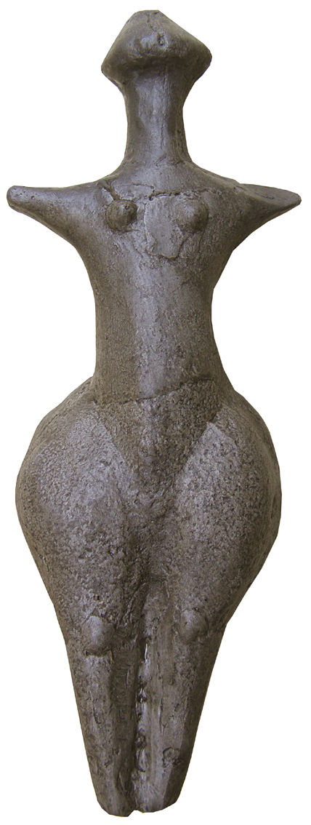 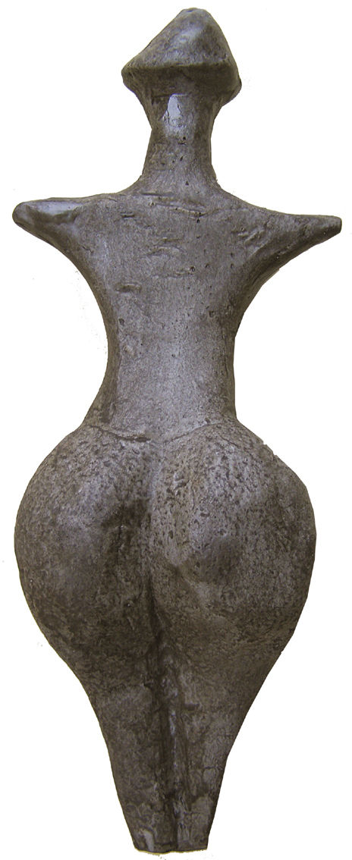

Formal Label: **Czech Republic, Moravia,** **Střelice, Venus Figurine**

Accession Number:

**LC Classification:** GN772

Date or Time Horizon: 4,700 - 4,300 BCE

Geographical Area: **Republic, Moravia,** **Střelice**

Cultural Affiliation: Neolithic

Medium: Fired clay

Dimensions: H 22 cm (8.7 in)

Weight:

Condition: Resin replica of original

Provenance:

**Discussion:**

**References:**